SOCI 33003: SOCIAL STATISTICS

Summer I 2025

Homework 4

(Due on June 20 (Friday), 2025 @ 12:00 pm)

NAME:

STUDENT ID:

Question 1 (20 pts)

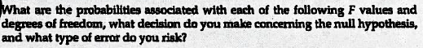

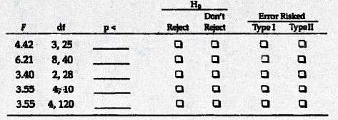

Question 2 (20 pts)

For the following data, please complete the ANOVA table

Sum of square | Sum of square | df | MSS | F | P | E²
Between
Within | 1811.96
total

Question 3 (30 pts)

For the following data, please answer the following questions

1) complete the ANOVA table (30 pts)

Sum of square | Sum of square | df | MSS | F | P | E²
Between
Within
total

2) what is the null hypothesis? (3 pts)

3) based on p, do we reject or not to reject the null hypothesis, and what type of errors incurred? (3 pts)

4) interpreting the eta-square (4 pts)

Question 4 (30 pts)

For the following data, please answer the following questions

1) complete the ANOVA table (30 pts)

Sum of square | Sum of square | df | MSS | F | P | E²
Between
Within
total

2) what is the null hypothesis? (3 pts)

3) based on p, do we reject or not to reject the null hypothesis, and what type of errors incurred? (3 pts)

4) interpreting the eta-square (4 pts)

