# SOCI 10103: General Sociology

# May Intersession 2025

# Homework 1

(Due on May 19 – Monday @ 4:00 pm)

**NAME:**

**STUDENT ID:**

**Question 1 (20%)**

The following map shows the suicide in Europe during 19th century. Explain how the sociological force explains the variability in suicide rate across different countries.

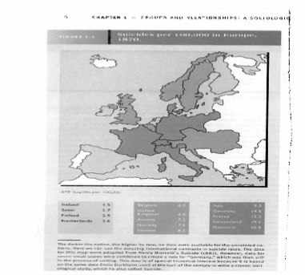

**Question 2 (30%)**

Take a look at the following graph, discuss the inductive and deductive approaches in sociology studies.

**Question 3 (30%)**

Take a look at the following graph, explain the third situation where multiple factors affect the suicide rate.

**Question 4 (20%)**

What is cultural shock, please provide a concrete real-life example of cultural shock.